IT24104275 – Weerarathna PGDD

PS – IT2120

1. Import the dataset (’Exercise – Lab 05.txt’) into R and store it in a data frame

called ”Delivery Times”.

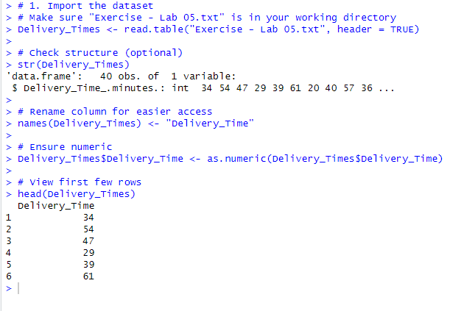

2. Draw a histogram for deliver times using nine class intervals where the lower limit

is 20 and upper limit is 70. Use right open intervals.

3. Comment on the shape of the distribution.

* The histogram of delivery times shows that most delivery times fall in the middle range (around 40–55 minutes), and the shape is approximately symmetric, close to a bell-shaped distribution.

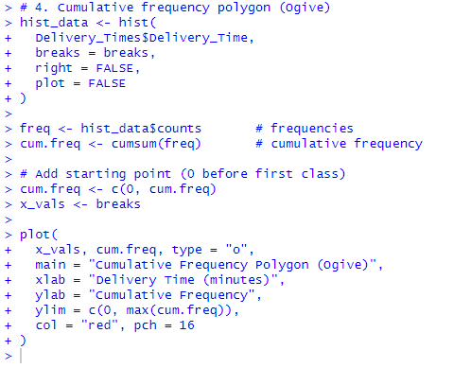4. Draw a cumulative frequency polygon (ogive) for the data in a separate plot.

